Progress History

“Simple Merge Program” Progress Report is about

how to create this program for a month

Written by Hyeontae Kim

Team 19

Github Repository : <https://github.com/caucse19/SE_TermProj>

Students :

Kim Hyeontae

Son Chang Woo

Kang Min Soo

Lee Jun ho

Park Jin Hyuk

Yang Insu

Semester : Spring 2018

Introduction

Simple Merge Program is comparing two file and merge each \*block. Has function that can load , save file and edit, compare, merge is also handled. Especially compare function, \*blocks are highlighted

\*block : a line that differ each file

We also use branch and separate folders in each section development , document

In document folder there are documents for Simple Merge Program like SRS , Usecases and imgs for documents with using ‘document’ branch.

In javasource folder there are java codes for our Simple Merge Program , with using ‘development‘ branch.

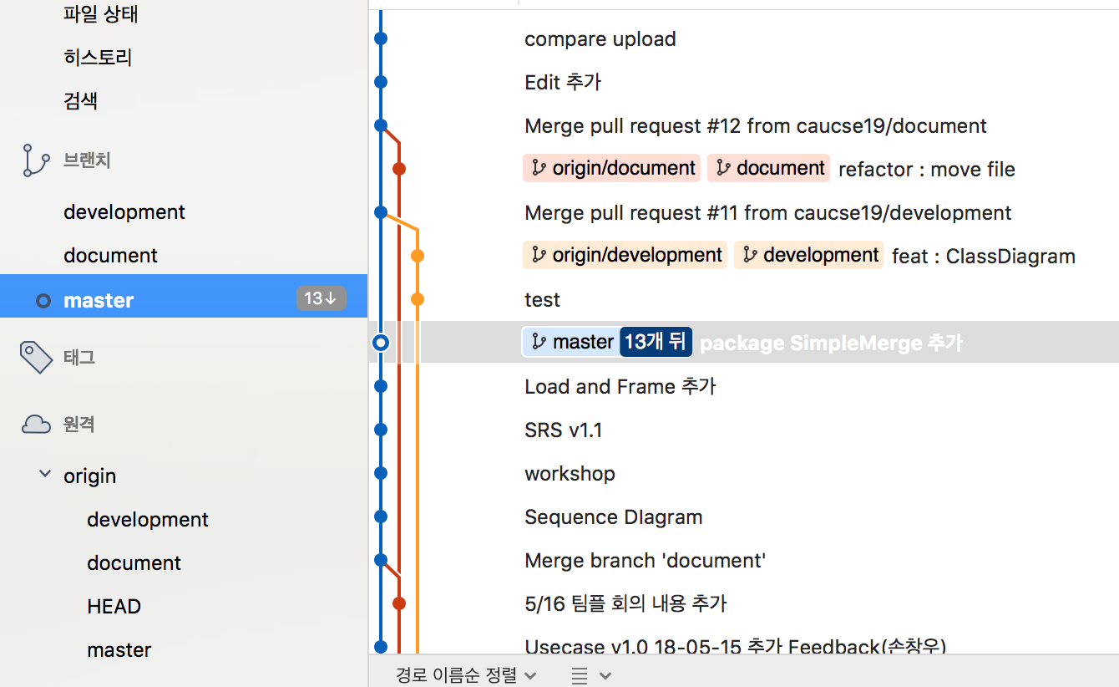

\* three branch in source tree program

Progress for a month

Week1

* Create Github repository
* Learn Source Tree Program for using git efficiently
* planning our project

Week2

* Specify Simple Merge programs goal
* Write Use Case and Misuse Case
* And other non-functional requirements
* Write SRS Document

Week3

* Edit SRS Document
* Create Base Program for Simple Merge Program
* Divide the work up between us

Week4

* Write Java Code for each part based on SRS Document
* Cummunicate each parts with Sequential diagram

Week5

* Test our program based on check list in Ecllipse Junit
* Merge “Simple Merge Program” in code
* Record our Project

Pic Logs

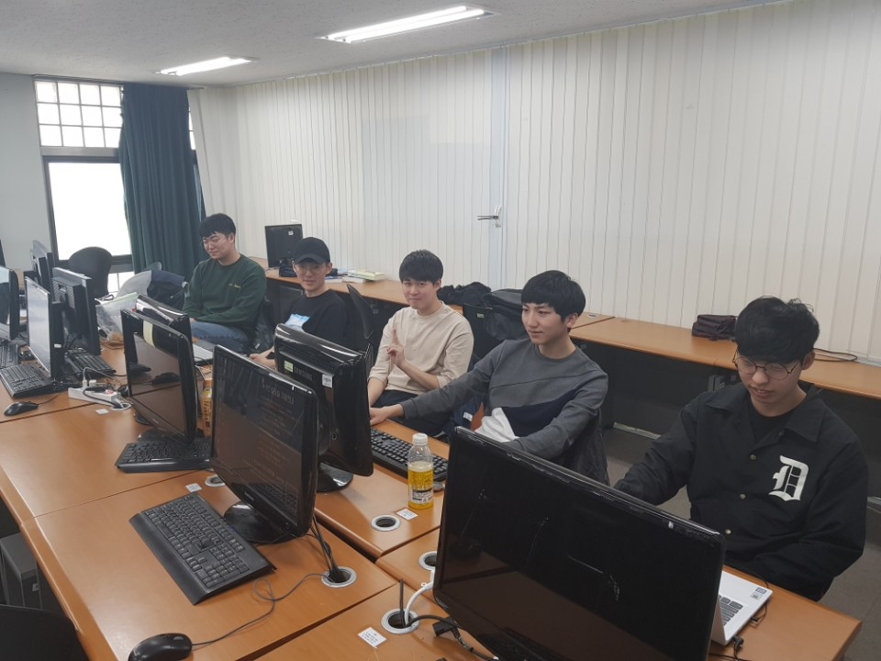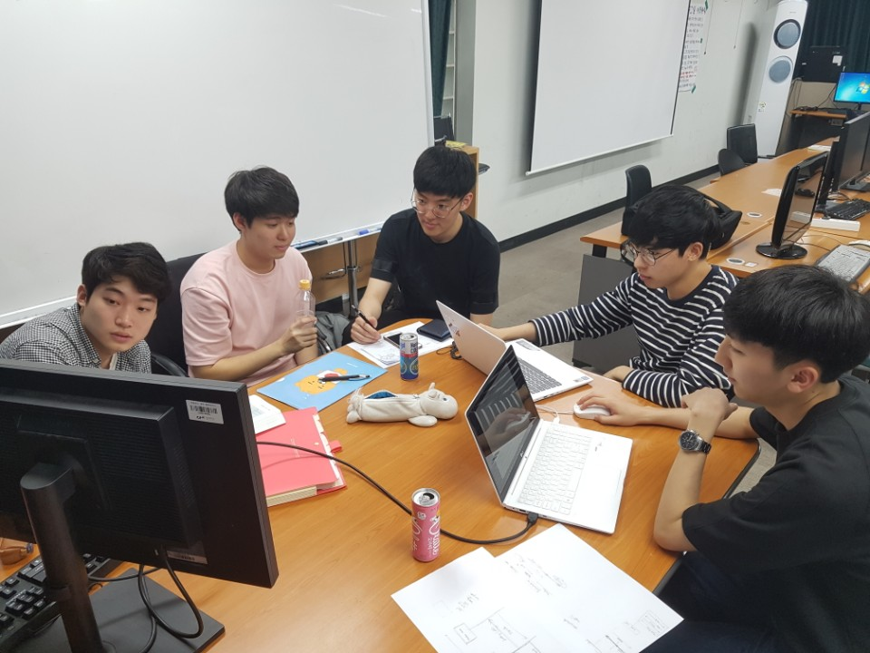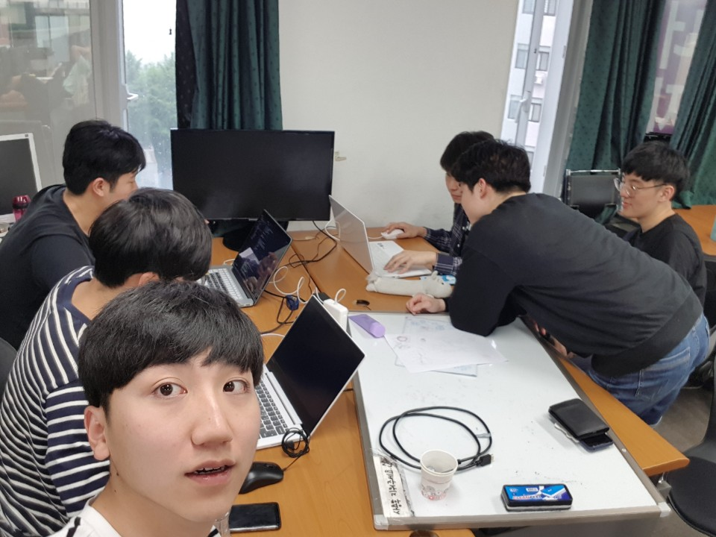

\*Issues

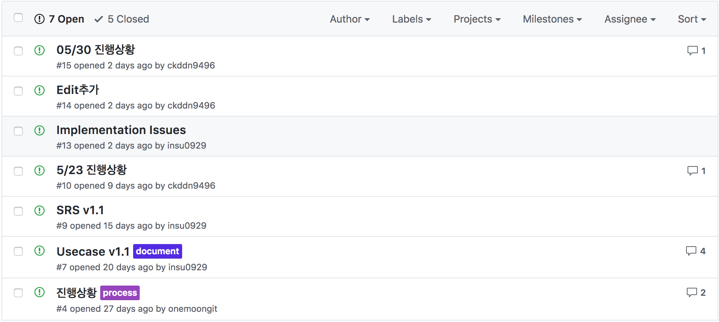

Summary

Simple Merge Program that we maded is very simple and powerful tool also easy to use in our GUI ( Graphical User Interface ).

… 추가

Experience